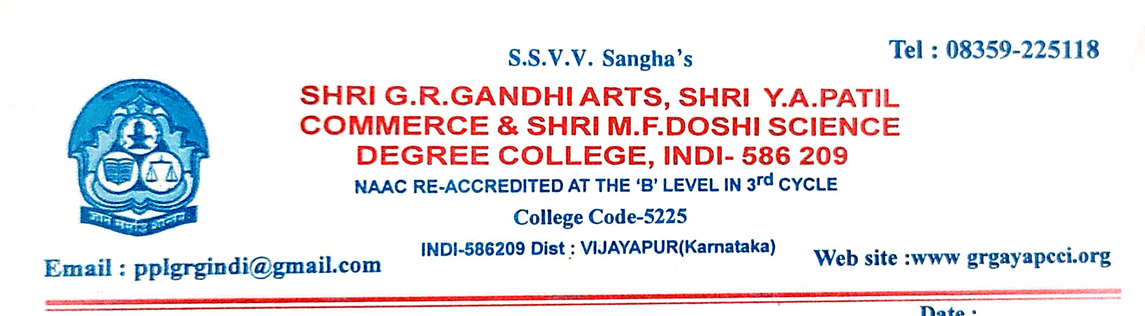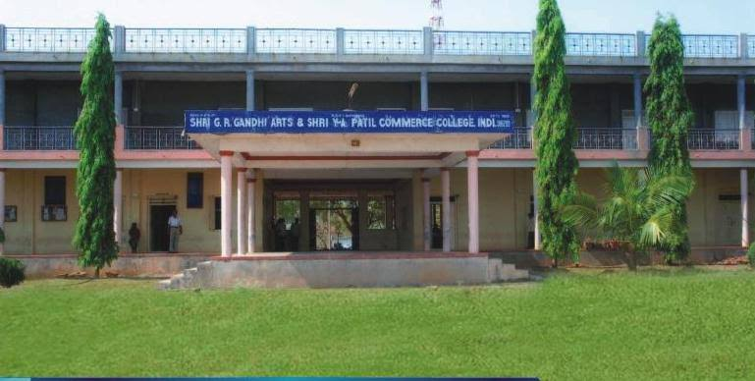

CRITERION VII - INSTITUTIONAL VALUES AND BEST PRACTICES

7.1.11 - Institution celebrates / organizes national and international commemorative days, events and festivals

7.1.11 - Institution celebrates / organizes national and international commemorative days, events and festivals
ANNUAL REPORT OF THE CELEBRATIONS AND COMMEMORATIVE EVENTS 2021-22
SI.NO | EVENT NAME | DATE | GUEST OF THE EVENT | NO.OF STUDENTS
01 | National Service Scheme Day | 24.09.2021 | Dr.Ramesh Kamble | 55
02 | Constitution day | 26.11.2021 | Prof.B.S.Patted | 95
03 | Subas Chandra Bose Jayanti | 24.01.2022 | Shri.Y.G.Biradar | 115
04 | Republic Day | 26.01.2022 | Shri.P.S.Bagali | 200
05 | D.R.Bendre Jayanti | 31.01.2022 | Shri.S.S.Irankeri | 70
06 | International Women’s Day | 08.03.2022 | Kumari.S.K.Bhagyashri | 85
07 | Environment Day | 06.06.2022 | Shri.S.B.Jadav | 50
08 | Yoga Day | 21.06.2022 | Shri.B.S.Patil | 70
09 | Independence Day | 15.08.2022 | Shri.P.S.Bagali | 115
10 | Rastriya Ekata Divas | 31.10.2022 | Dr.Jayprasad D | 62
11 | Kanakdas Jayanti | 11.11.2022 | Shri.Shrishail.G.Sannakki | 80
12 | Constitution Day | 26.11.2022 | Shri.Ishwar.S.M | 90
13 | Aids Day | 02.12.2022 | Shri.S.M.Ishwar | 55
14 | National Maths Day | 22.12.2022 | Shri.Dattatrey Hadpad | 55
15 | Savitribai pule Jayanti | 03.01.2022 | Mrs.Suma.Patil | 50
16 | Onake obavva Jayanti | 11.11.2021 | Dr. Jayaprasad D | 62
17 | National Science day | 28.02.2022 | Dr. Girija. Nimbal | 150
18 | Leagal awareness day | 26.11.2022 | Shri.Ishwar S M | 45

Annual Report on Celebrations of Commemorative Events 2020-21
India is known for its cultural diversity and colourful festivals. Institution celebrates/ organizes national and international commemorative days, events and festivals. National festivals play an important role in planting seed of Nationalism and Patriotism among people of India. Our institution celebrates these events with great enthusiasm to commemorate the ideology of nationalism and to pay tribute to our great National Leaders. The Faculty, Staff and Students of the institution all come together under one umbrella to celebrate these occasions and spread the message of Unity, Peace, Love and Happiness throughout.
To maintain harmony and healthy work atmosphere and to make the learners aware of the national pride and rich cultural heritage, the National/International commemorative days are regularly being celebrated and observed in the campus.
For the academic year 2020-21, we celebrated the various days like World Environment Day, International Yoga Day, Independence Day, Republic Day, International Women’s Day, National Science Day, Mathematics Day, Science Day etc. We also celebrated Birth Anniversaries of Dr. Sarvapalli Radhakhishnan, Smt. Savitribai Phule, Swami Vivekananda, Subhaschandra Bose, Onake obbava etc. The college also believes that education will allow the students to bloom, blossom, giving them the right platform where they will work towards becoming a responsible citizen

